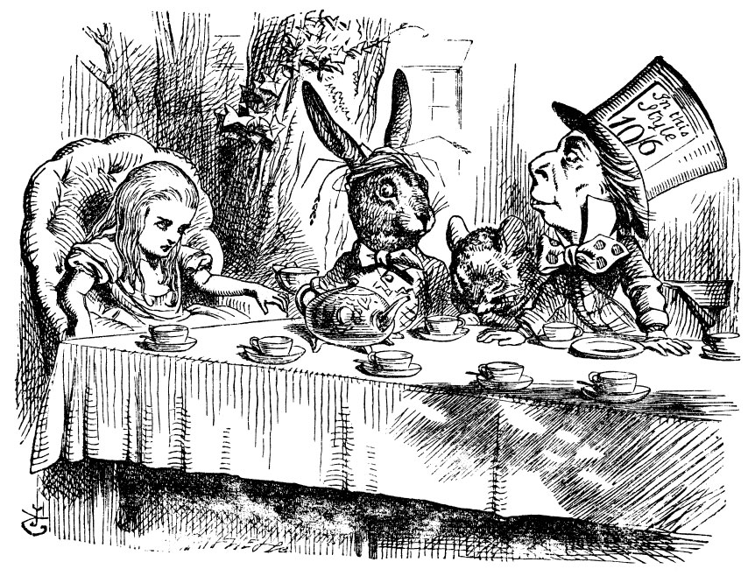
“Alice: Would you tell me, please, which way I ought to go from here?
The Cheshire Cat: That depends a good deal on where you want to get to.
Alice: I don't much care where.
The Cheshire Cat: Then it doesn't much matter which way you go.
Alice: ...So long as I get somewhere.
The Cheshire Cat: Oh, you're sure to do that, if only you walk long enough.”
― Lewis Carroll, Alice in Wonderland

Hello everyone!

My name is Todd Jobbitt. I have been living and teaching English for nearly 20 years in Seoul. Teaching is a wonderful job that allows me to meet new people, live abroad, and travel.

Work takes up a lot of my time, but my other main job is raising my children: Lana and William. They both keep my wife, Sunyoung, and me very busy! I love to go out and exercise with my kids – usually running, biking or swimming.

In my free time, I like to watch action movies (like Batman, The Avengers, etc.), and TV shows like The Terminal List, DC Legends, Kung Fu, etc.). I love science fiction, too, both movies (Star Trek, ) and TV shows (like The Expanse and The Sandman). I especially like reading novels (sci-fi, action, and historical fiction) and graphic novels. Music is also a passion, all genres: ambient, jazz, pop, rock, indie rock, etc.

My home state is Michigan (USA), a very beautiful state with quick-changing weather. It’s similar to Korea’s weather, but colder in the winter and almost as humid in the summer. It’s famous for the Great Lakes, Motown music (Detroit), and cars.

Well, enough about me. Let’s hear about you! Write back to me, and tell me about your family, hobbies, things you don’t like or are afraid of, your personality, favorite things, countries you’ve visited, goals in life, or anything else that you would like me to know about you.

I am looking forward to our busy semester! It is a new adventure for you, just as much as it is for me. I know that we will have a great time working together this term!

Warm regards,
Todd

